HOW TO INSTALL WINDOWS 11 PRO

REQUIREMENTS

•

A PC with at least one storage drive, preferably

unformatted, but not required. Minimum Windows

11

hardware requirements

are listed her

[e](https://binaryfork.com/windows-11-system-requirements-641/)

. Note

the TPM module requirement. Your computer

might have one but

needs to be enabled in BIO

[S](https://binaryfork.com/enable-tpm-module-651/)

.

•

A bootable USB disk 8 GB or larger.

•

A working computer with an Internet connection

so you can download Windows

ISO disk

image

and create a bootable disk.

2023

HOW TO INSTALL WINDOWS

11

2

HOW LONG DOES

IT TAKE TO

INSTALL

WINDOWS

1

1

?

From booting your PC to the Windows

desktop, it can take anywhere between 10 to

15

minutes to install Windows 11 on modern

hardware.

2023

HOW TO INSTALL WINDOWS 11

3

# GOOD TO KNOW

If you already have a Windows install medium (DVD or USB key) you don’t need a working computer to create the installer disk.

4

|  |
| --- |
| [**Recommended read**:](https://binaryfork.com/bootable-usb-disk-rufus-960/) [How to download Windows 11,](https://binaryfork.com/bootable-usb-disk-rufus-960/) [How to create a USB bootable disk,](https://binaryfork.com/bootable-usb-disk-rufus-960/) [How to install Windows 11 on hardware that doesn’t meet minimum requirements](https://binaryfork.com/install-windows-11-incompatible-computer-1864/) |

HOW TO INSTALL WINDOWS 11

STEP 1:

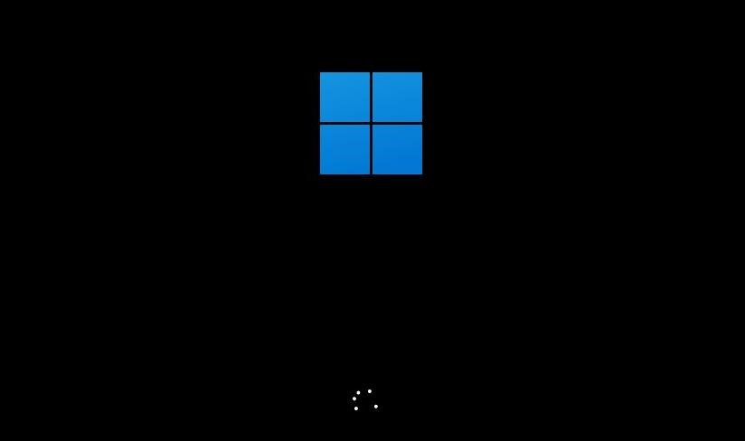

Insert the bootable DVD into the optical bay or the USB disk into your computer.

|  |
| --- |
| **Note:** if using a desktop case try to insert the USB drive into one of the rear ports. Front-panel USB connectors are more convenient to use but can cause issues during the install process. |

STEP 2:

**Press the F8 key** multiple times while the computer starts to call the Boot Manager menu.

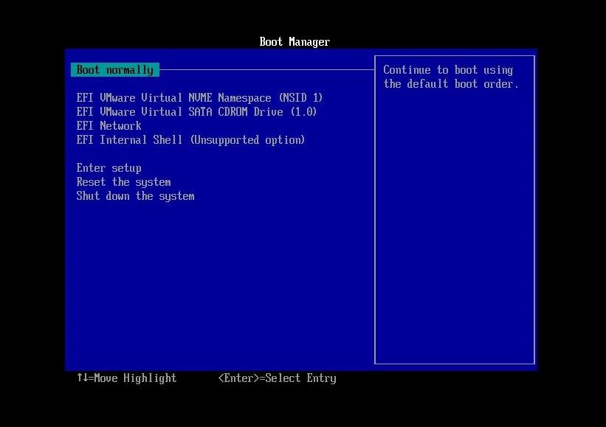

STEP 3:

Use the arrow keys to **select the drive unit** that contains the Windows 11 installer. Some drives may show up twice. If so, I recommend you chose the version that’s named EFI or UEFI. This is the best way to install Windows 11 and it’s a hassle to switch to UEFI after installing the OS in legacy BIOS mode.

STEP 4:

Next, a message to **Press any key to boot from the CD or DVD…** appears. Doing so will start the actual Windows 11 installation process and the new Windows 11 flat logo will show up.

STEP 5:

First step is to choose to

**Install now**

. On this screen, you’ll

also see an option to

*Repair your computer*

. You’ll ignore it

for this guide.

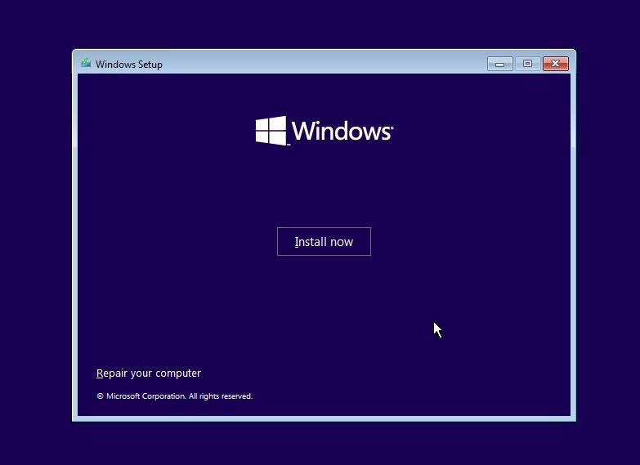

STEP 6:

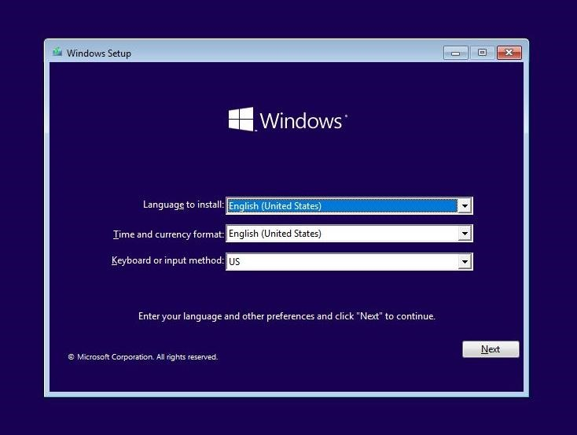

The installer will ask now to choose the **language of the interface, the time and currency format, and the keyboard layout**. These can be mixed and matched to your preference, and don’t need to reflect reality. Changing them at a later date is possible without reinstalling Windows 11.

STEP 7:

At the next step you’ll be asked to **enter the Windows 11 product key**. This step can be skipped for now, but you’ll have to eventually activate Windows 11 to get all the features (find out [what happens if you don’t activate Windows)](https://binaryfork.com/windows-10-no-activation-542/).

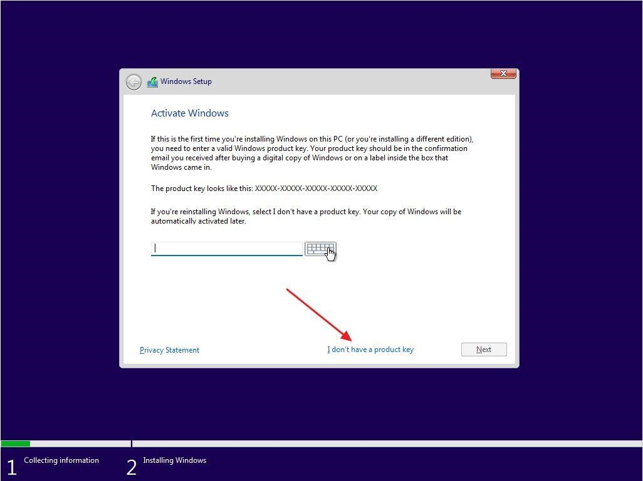

Be careful and enter the correct code provided with your license. The serial key is made up of 25 characters (5 groups of 5 letters and numbers each).

STEP 8:

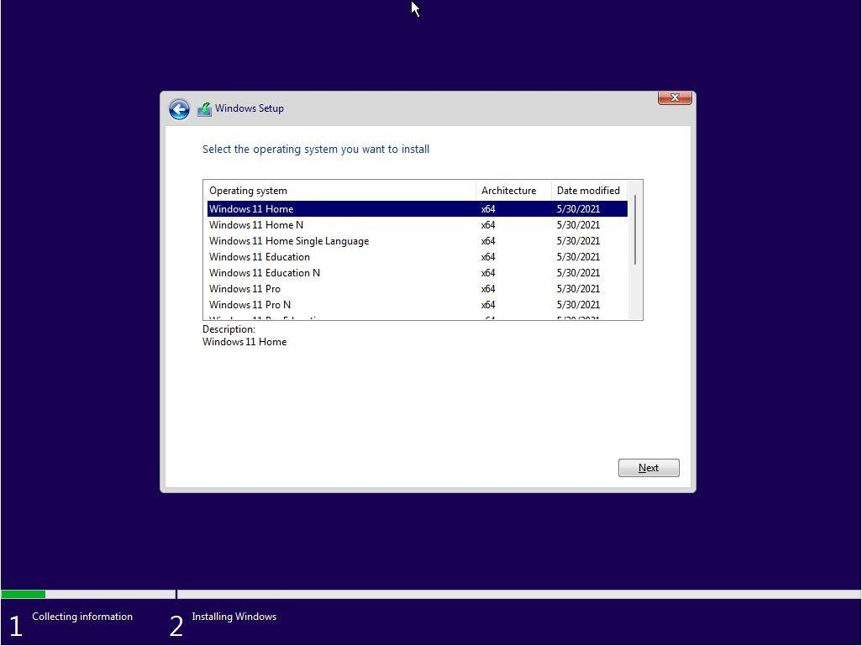

Now it’s time to **select the Windows edition** you want to install. Your selection **must match the product key entered earlier** or else Windows won’t activate.

You can’t buy a Windows 11 Home license and activate Windows 11 Pro.

STEP 9:

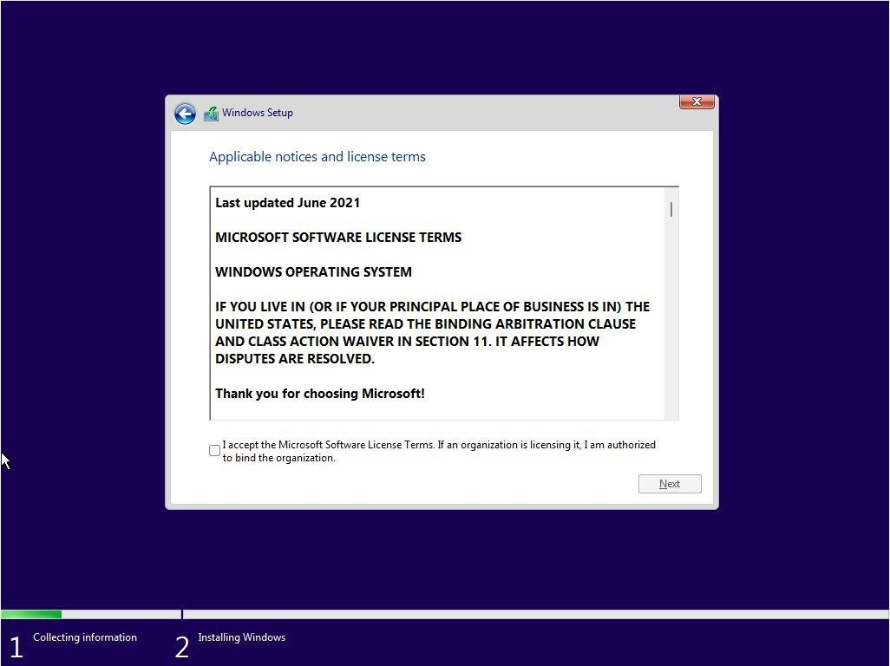

To proceed you need to **agree to the licensing terms** (EULA) at this step. Check the “I accept…” box and click Next.

STEP 10:

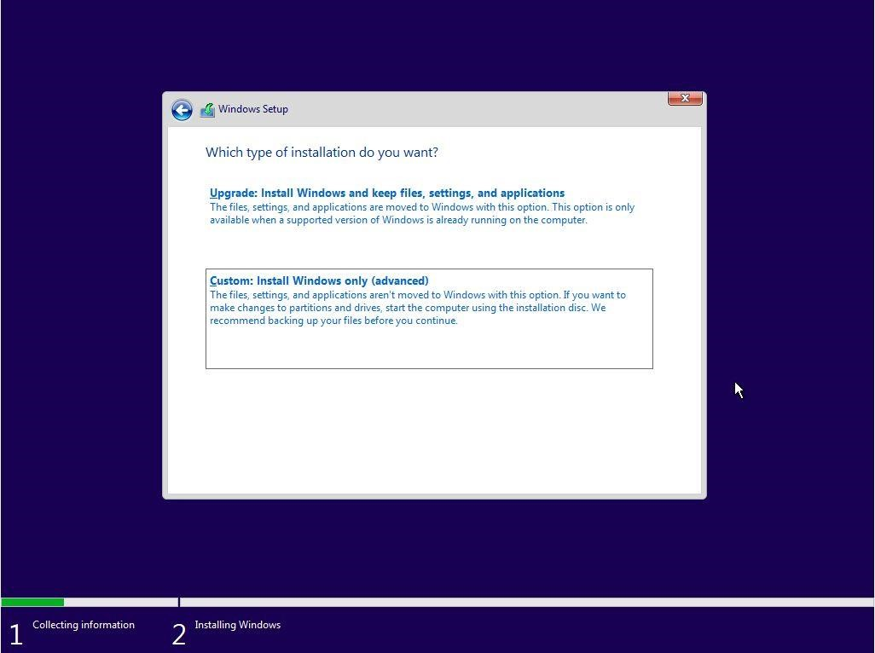

Next select the installation type. There are two options: **Upgrade** an existing installation of Windows (version 7, 8, or 10) or **Custom**. Select the latter option to continue.

STEP 11:

At this step you’ll see all available disks detected in your computer. Let the installer know the **disk where Windows 11 files will be copied**. You can choose to partition the existing disk into smaller virtual disks (recommended for bigger disks). If you only have one unformatted disk just select it and hit Next. The installer will create all the needed partitions for you.

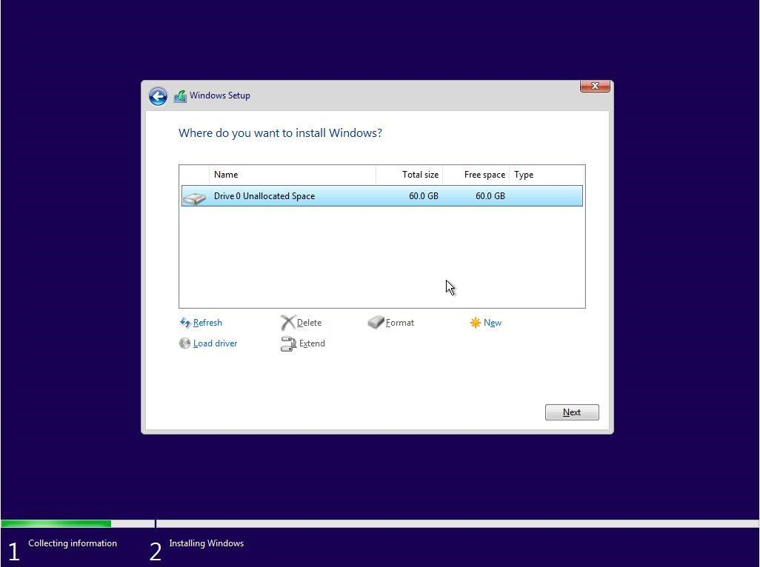

STEP 12:

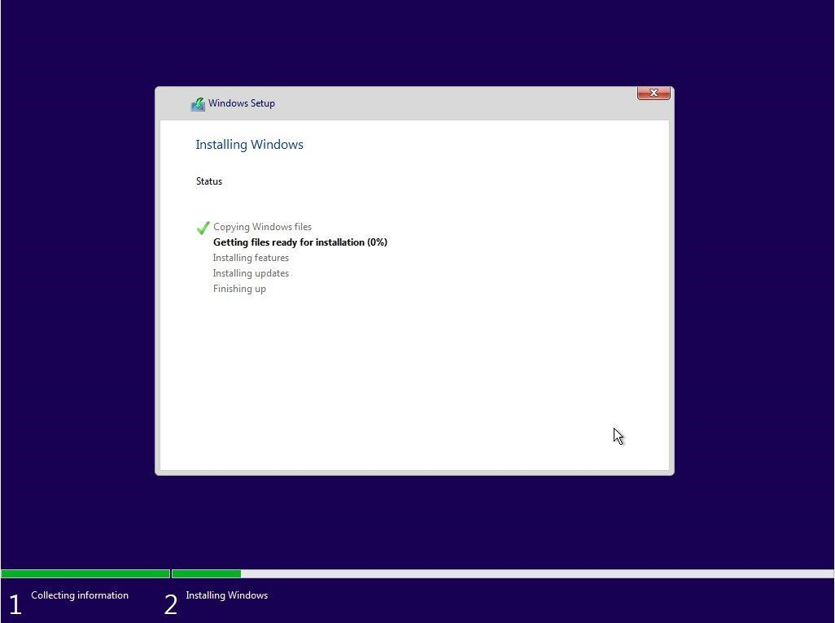

The installer will now start to **copy the required files** from the install medium to their destination. A computer reboot will happen at this point.

STEP 13:

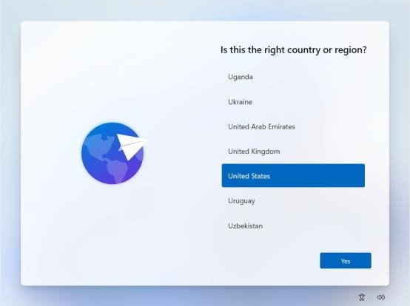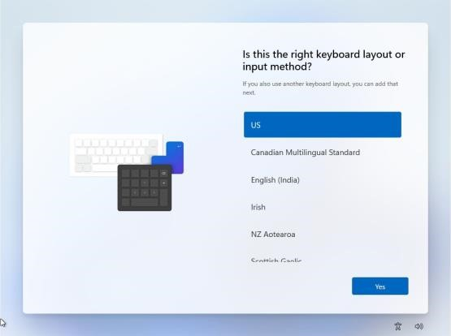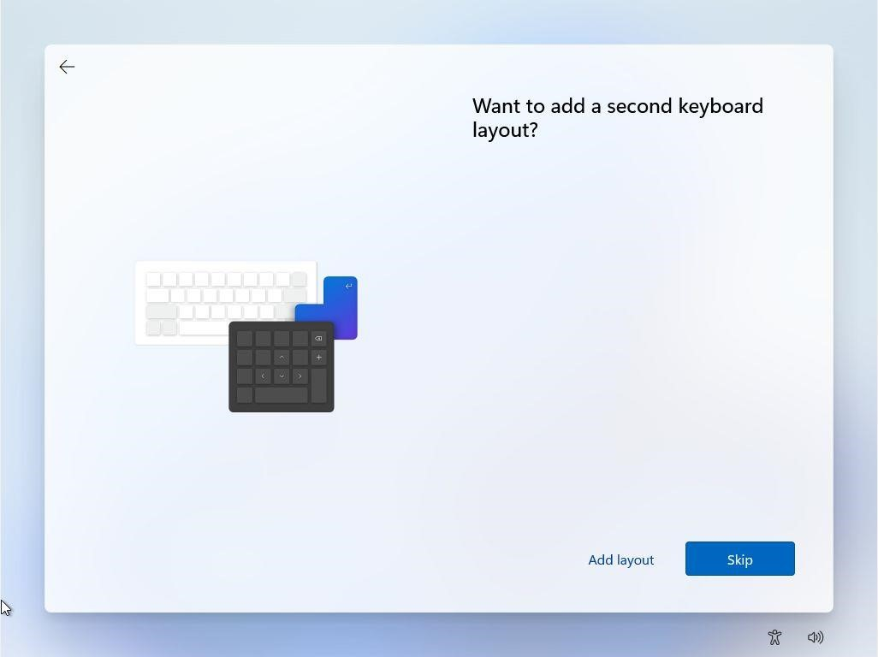

If this is a deja-vu, don’t worry, because you’re asked again to **select the geographical region and keyboard layout**. They can differ from the original choice and will override the settings from step 6. You can optionally **add more keyboard layouts** (hint: use WIN + Shift to switch between them while using Windows).

STEP 14:

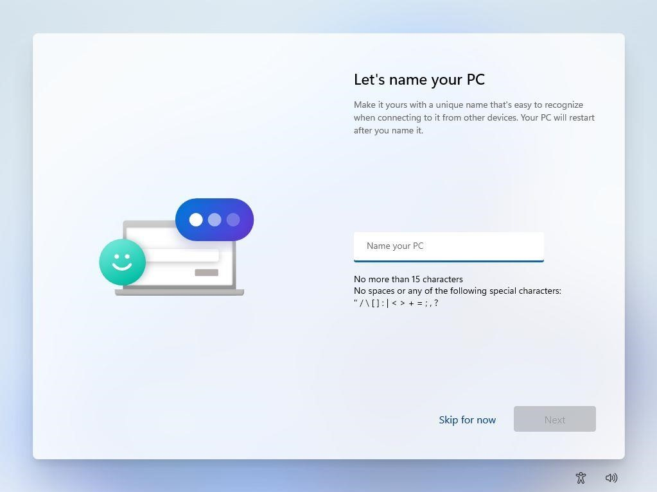

All previous screens are almost identical to the [Windows 10 installer.](https://binaryfork.com/install-windows-10-step-by-step-428/) Now we’re getting the first newly designed screen: **name your PC**. I suggest you enter a computer name that’s recognizable and easy to remember.

STEP 15:

The installer will now **check for any updates** and download them before proceeding. Let it do its thing.

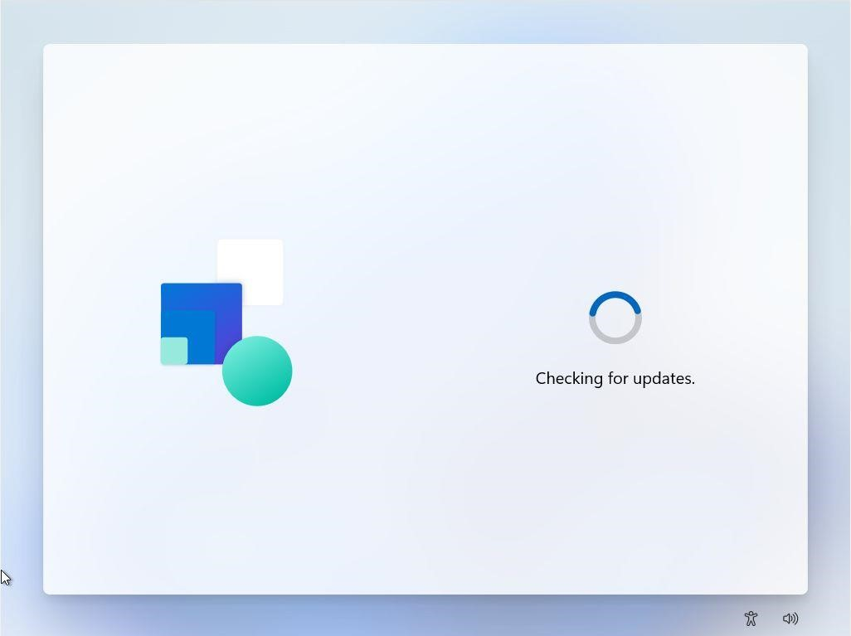

HOW TO INSTALL WINDOWS 11

STEP 16:

At this next step you’ll select the predefined device usage scenario: for **Personal use** or **Organization**, in which case your system administrator will enforce some settings for you after you login into your company network. We’ll be using the Personal option for this guide.

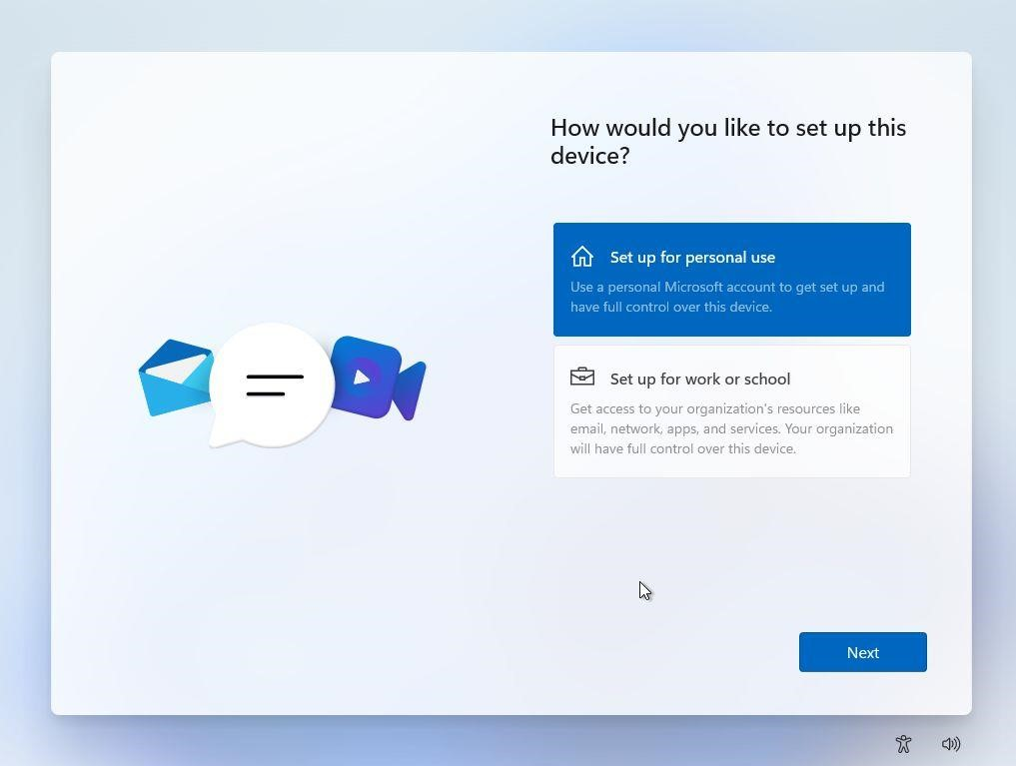

HOW TO INSTALL WINDOWS 11

STEP 17:

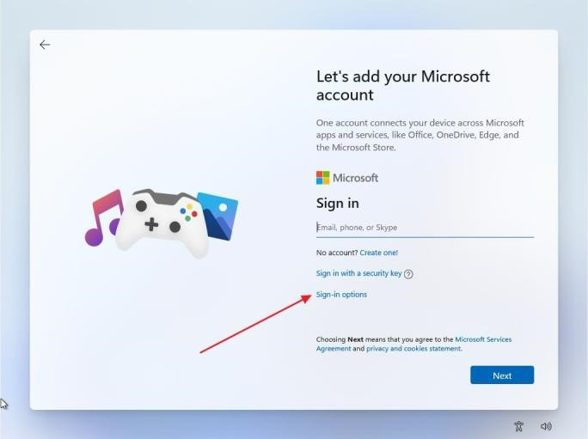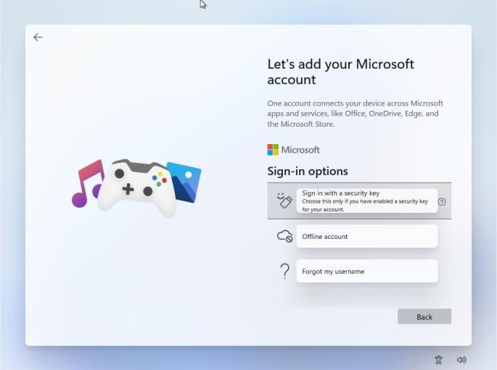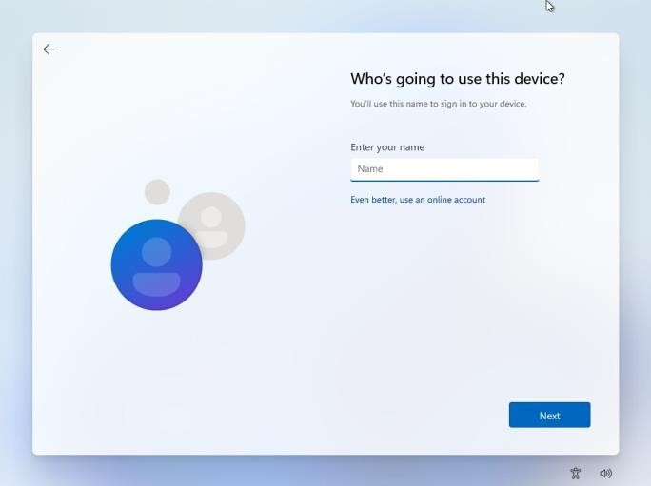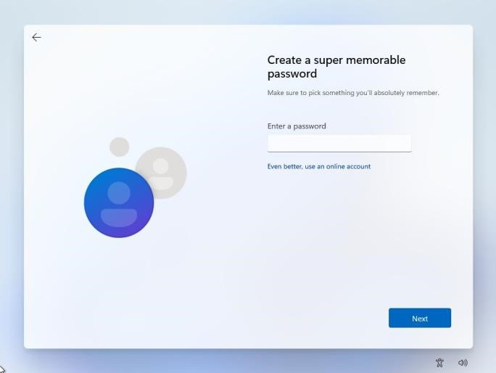

Now it’s time to **create the administrator account** for this PC. Microsoft still tries to make you sign in with your outlook.com account, but I suggest you stick to an offline account for privacy reasons. We also have an [article detailing the differences between the two account types.](https://binaryfork.com/windows-online-vs-local-account-2061/)

STEP 18:

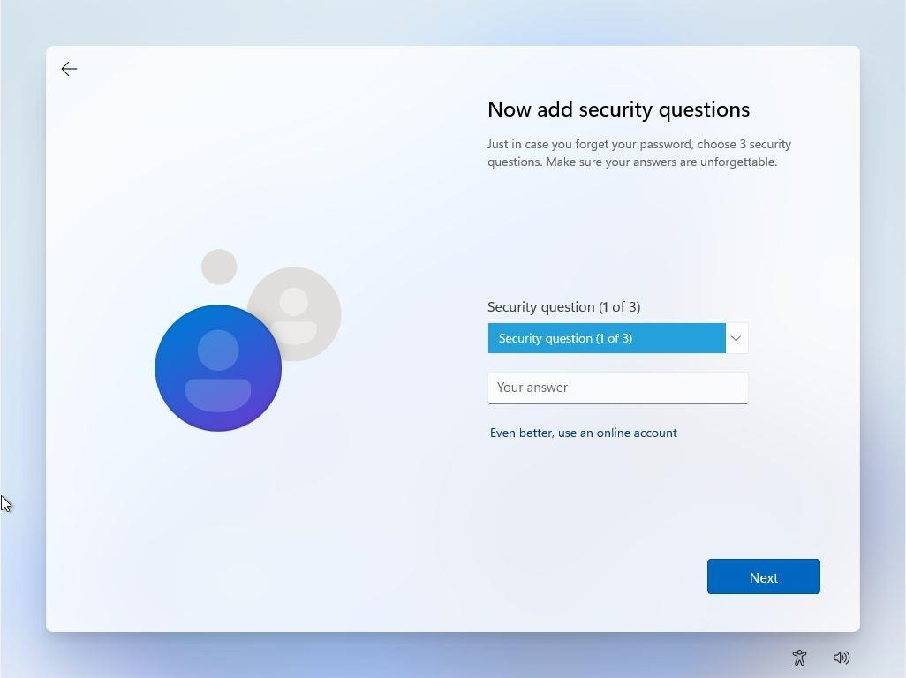

To ensure you can recover your files if you don’t remember your password, you’ll need to provide answers to one of the **3 security questions** set up at this step.

If you sign in with a Microsoft account, you will be asked

to

**Create a PIN**

to log in quicker to your computer, instead

of using the complex Microsoft password.

You can complete a more secure PIN if you wish, but by

default, you’re only required to add numbers, not letters

and symbols.

STEP

1

8

(A

)

:

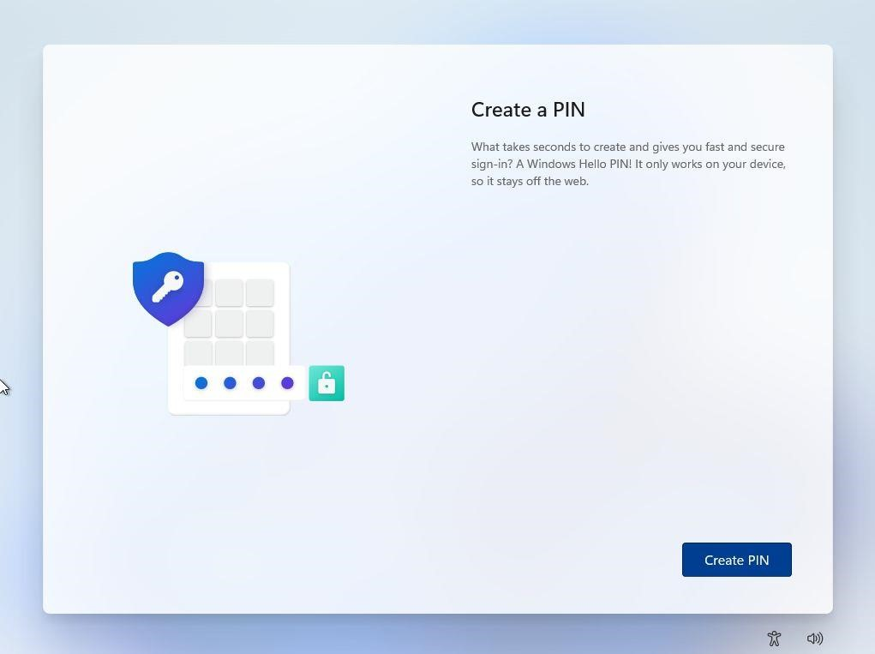

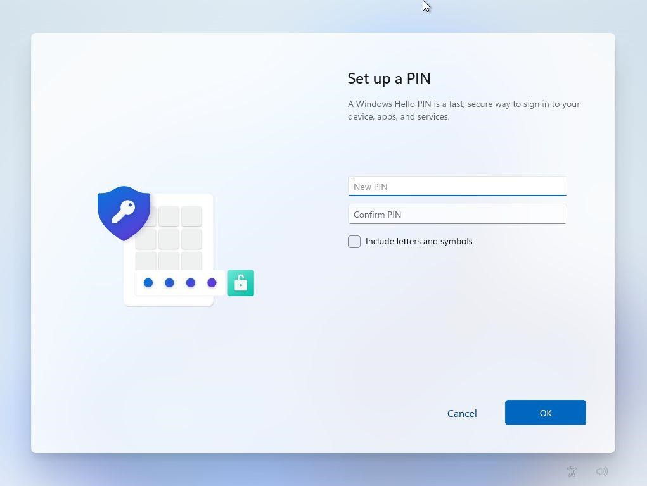

For this guide, we’ll just select **Set up as new device**.

If this is not your first Windows device and you had set up

settings sync in the past, you can choose to restore settings from

another machine (it can also be the same machine if you’re

reinstalling Windows).

By default, Microsoft shows the last device that was synced, but

you can click on the

*Restore from another device*

link and you will

see a list of all devices associated with your Microsoft account. 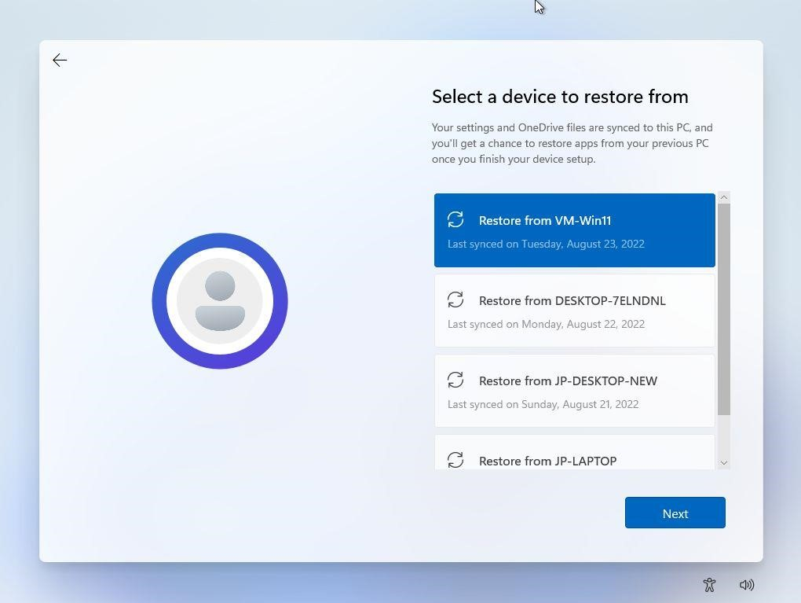

STEP

19

:

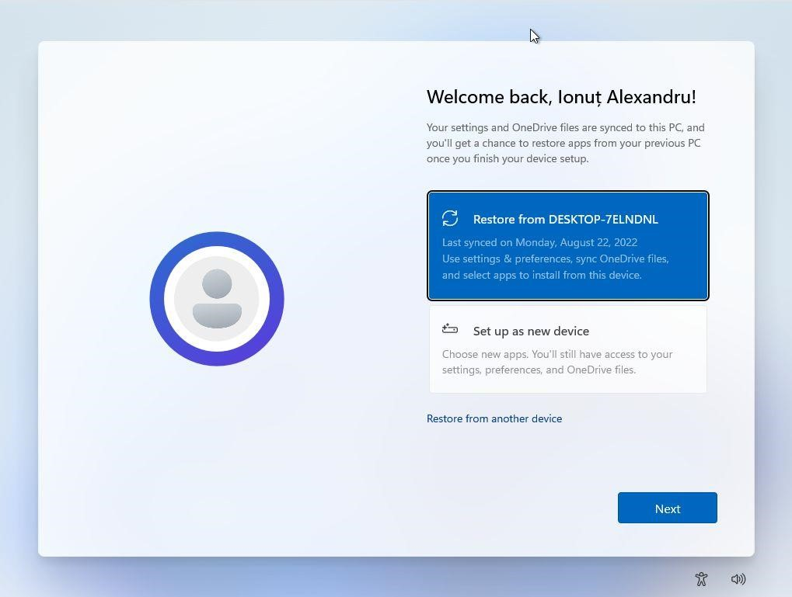

STEP 20:

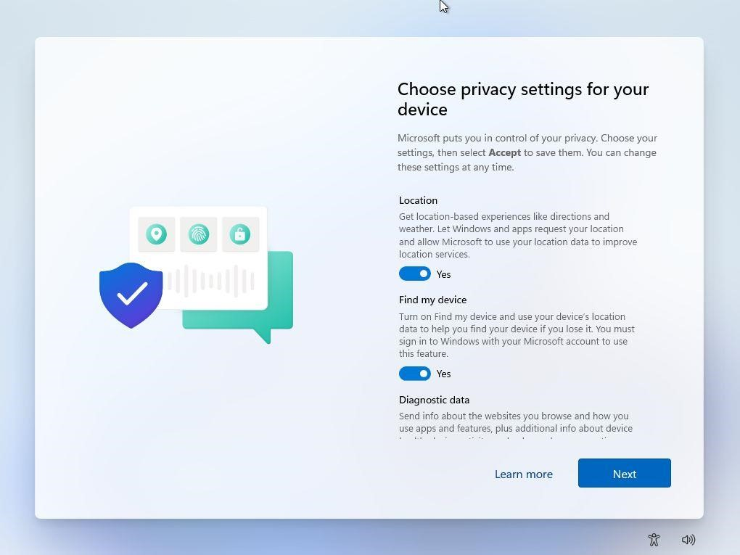

**Privacy settings** are next. By habit, I disable everything that’s possible without hampering the use of Windows. Expect some telemetry data to still be sent to Microsoft, but I’m working on an article about how to disable pretty much everything that affects privacy in Windows 11.

STEP 21:

This is a new step, which will ask you to select the basic types of activities you’ll be doing with your new machine. Options include Entertainment, Gaming, School, Creativity, Business, and Family.

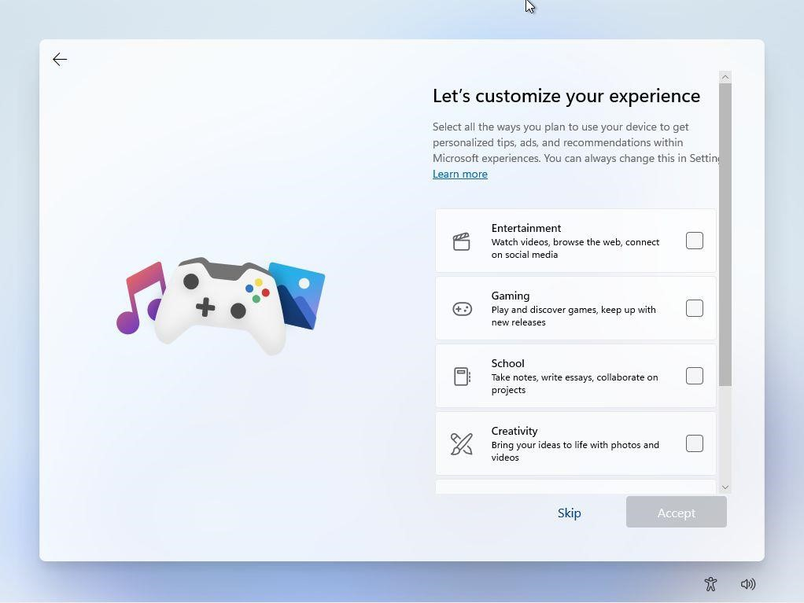

Based on your selection Windows will personalize tips, ads, and recommendations. You can just press *Skip*, as all these options can be changed later in the Settings app in the *Personalization* > *Device Usage* section.

STEP 22:

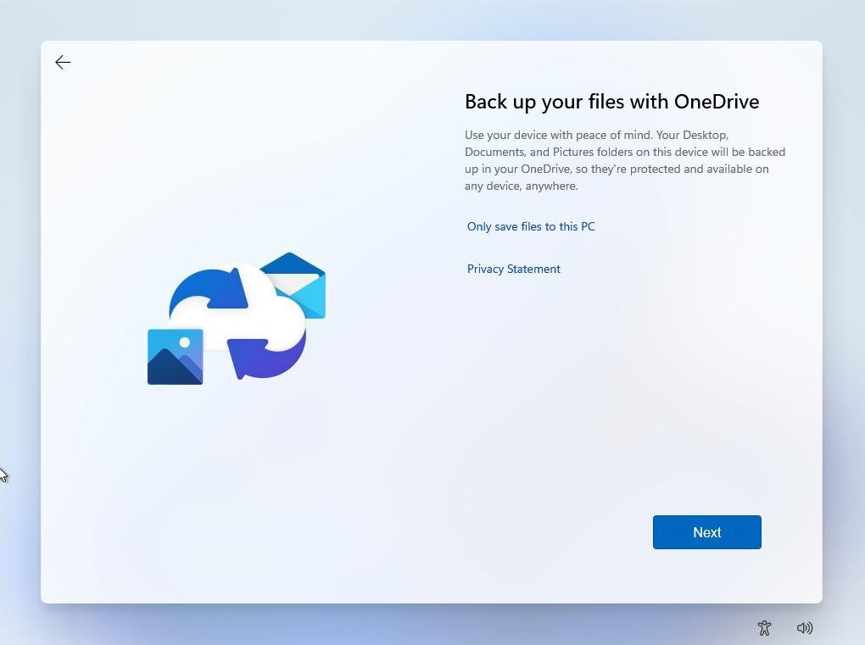

You’ll now be asked to set up an automatic backup with OneDrive. It’s part of the Windows settings sync. You can just click on the *Only save files to this PC link* and continue.

If you want to [set up OneDrive, follow this complete guide.](https://binaryfork.com/onedrive-windows-5450/)

STEP 23:

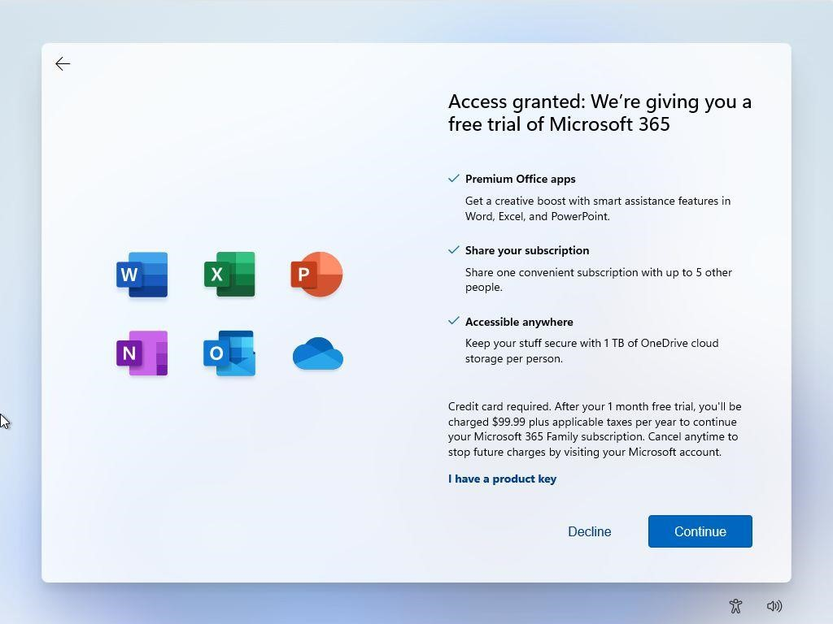

Now you can set up your Microsoft 365 Family plan 1 monthly trial for Office + 1TB OneDrive cloud space. If you don’t need it click *Decline*. If you already have an active subscription, you can click on the *I have a product key* to link this device.

STEP

2

4

:

Another promo, this time for Xbox Game Pass. It’s a pretty

good deal if you’re a serious gamer. You can press

*Skip for*

*now*

to proceed further.

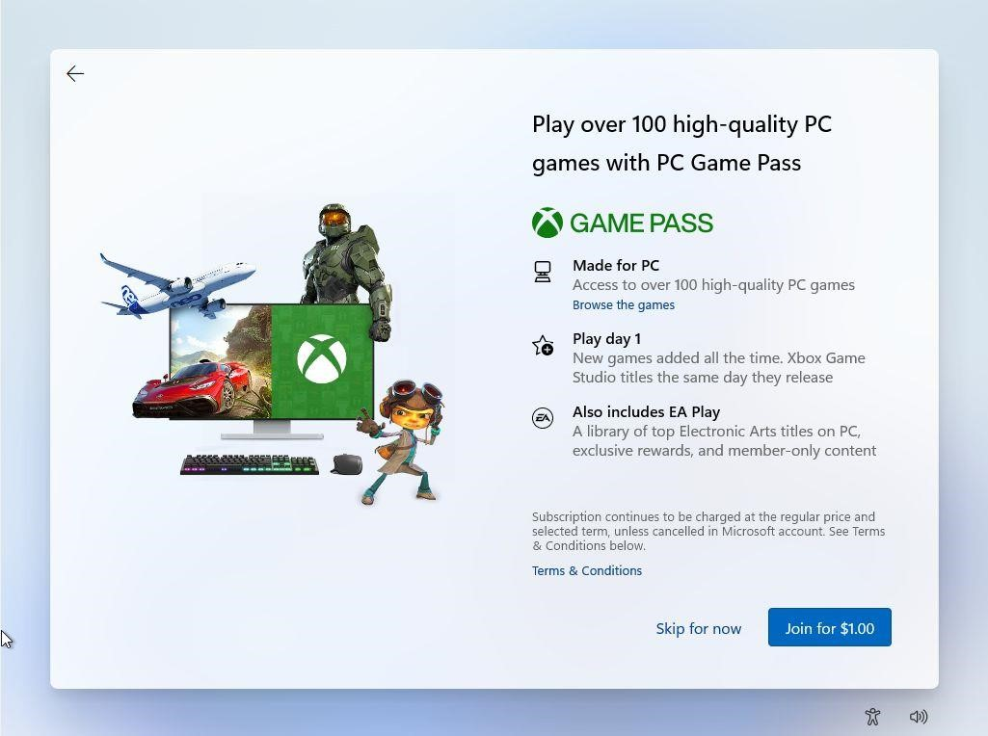

STEP 25:

After a few moments and a couple of different screens you’ll be greeted with the new Windows 11 desktop for the first time. Don’t worry, the start menu is supposed to be centered!

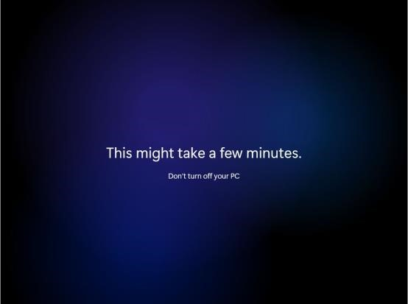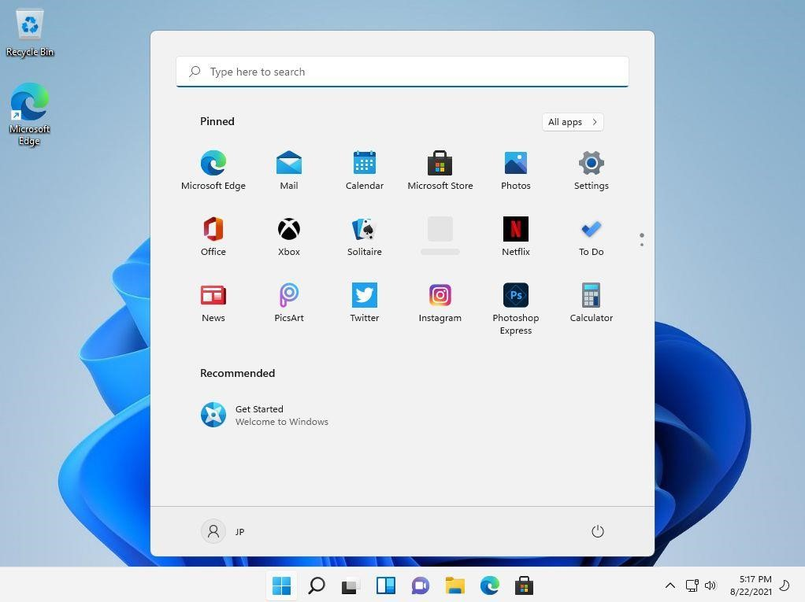

That’s it. You’ve successfully installed Windows 11 on your new computer!

HOW TO INSTALL WINDOWS 11

How To Set Up Python Environment.

**Installation on Windows**

Visit the link [*https://www.python.org/downloads/*](https://www.python.org/downloads/)

to download the latest release of [Python](https://www.javatpoint.com/python-tutorial). In this process, we will install Python 3.8.6 on our [Windows operating system](https://www.javatpoint.com/windows). When we click on the above link, it will bring us the following page.

Step - 1: Select the Python's version to download.

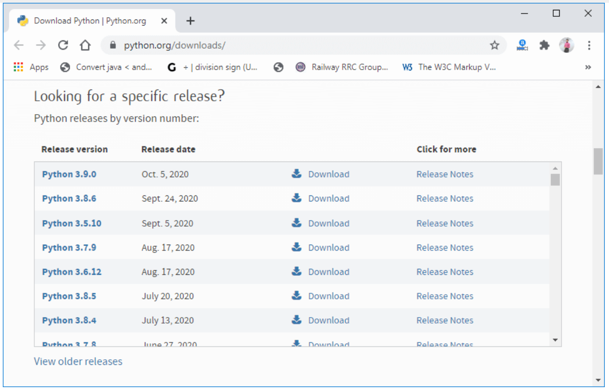

Step - 2: Click on the Install Now

Double-click the executable file, which is downloaded;

the following window will open.

Select Customize installation and proceed.

Click on the Add Path check box, it will set the Python path automatically.

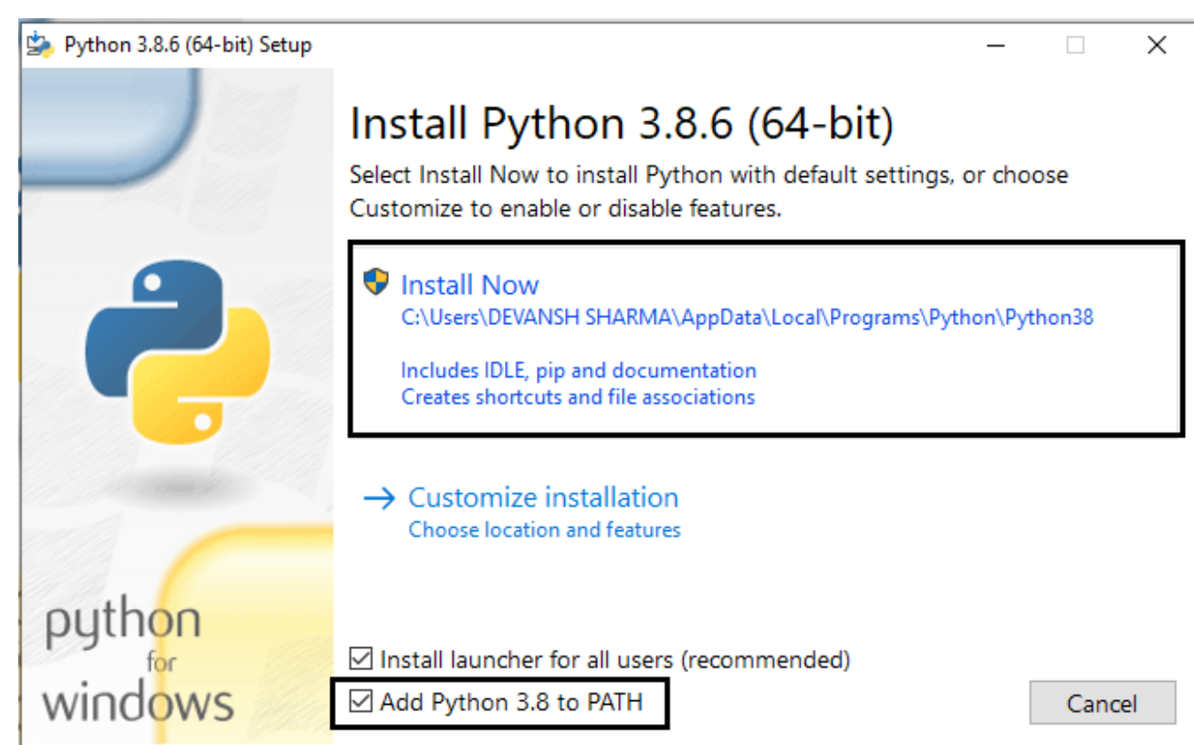

We can also click on the customize installation to choose desired location and features. Other important thing is install launcher for the all user must be checked.

Step - 3 Installation in process.

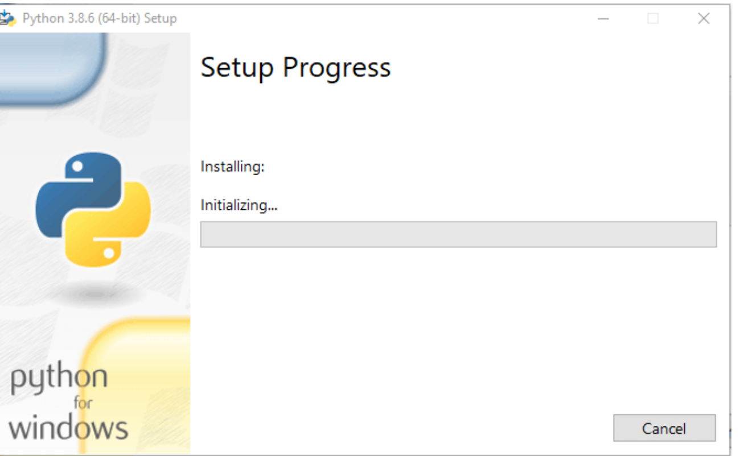

Now, try to run python on the command prompt. Type the command python -version in case of python3.

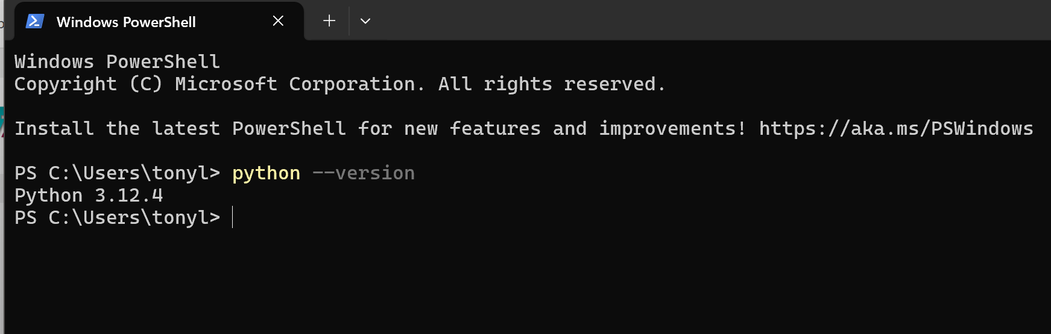

How To Set Up Visual Studio Code.

1. Setting up Visual Studio involves a few steps. Here's a concise step-by-step guide:
2. **Download Visual Studio:**
3. Visit the [Visual Studio website](https://visualstudio.microsoft.com/) and click on "Download Visual Studio."
4. Follow the on-screen instructions to download the installer.
5. **. Run the Installer:**
6. Run the downloaded installer.
7. Choose the "Visual Studio" workload during installation, which includes the necessary components for general development.
8. **. Select Workloads and Components:**
9. In the Visual Studio Installer, select the workloads and components you need based on your development requirements. Common workloads include ".NET Desktop Development" or "Web Development.

Step 2 after successfully installation

Click windows icon 

And search vs code the click on it

It open a page same as below

